CUSTOMER

* First, you need to go to the homepage of CleckShopHub, then click on the Login button from the top right of the navigation bar

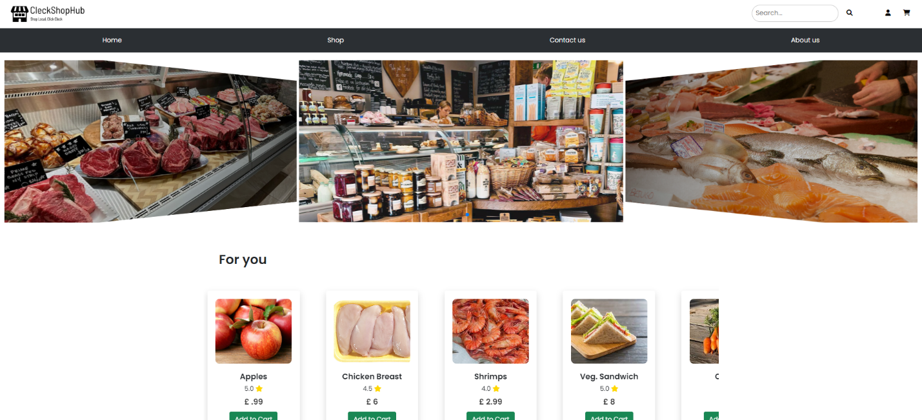

[Register Testing]

* If you click on Sign Up button without entering anything in the input fields then all the empty fields are highlighted in red

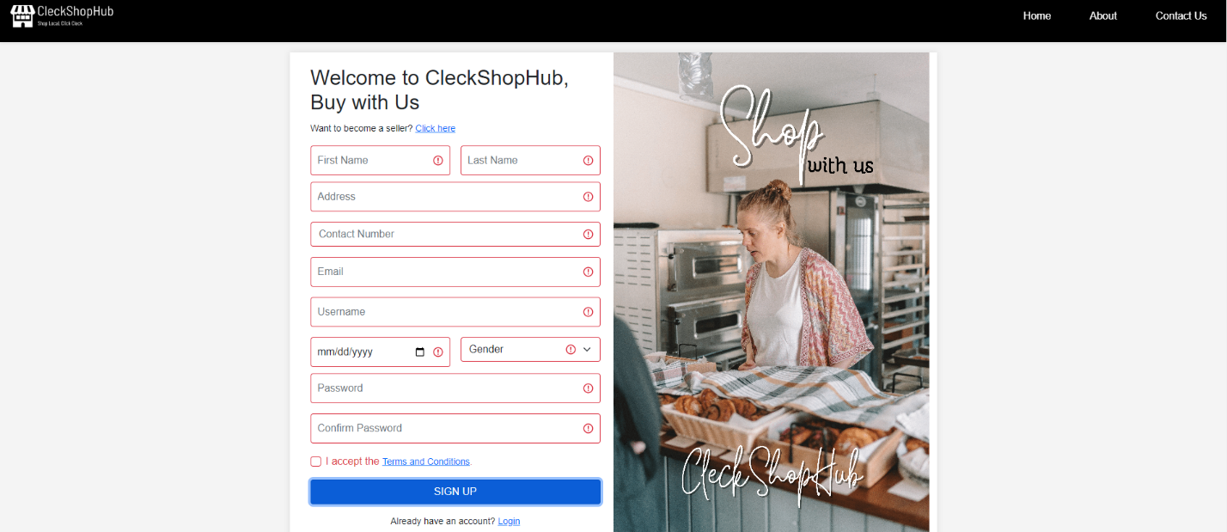

* If you input contact number which is lesser or greater than 10 digits then an error message will be highlighted instructing user to enter contact number that is exactly 10 digits long

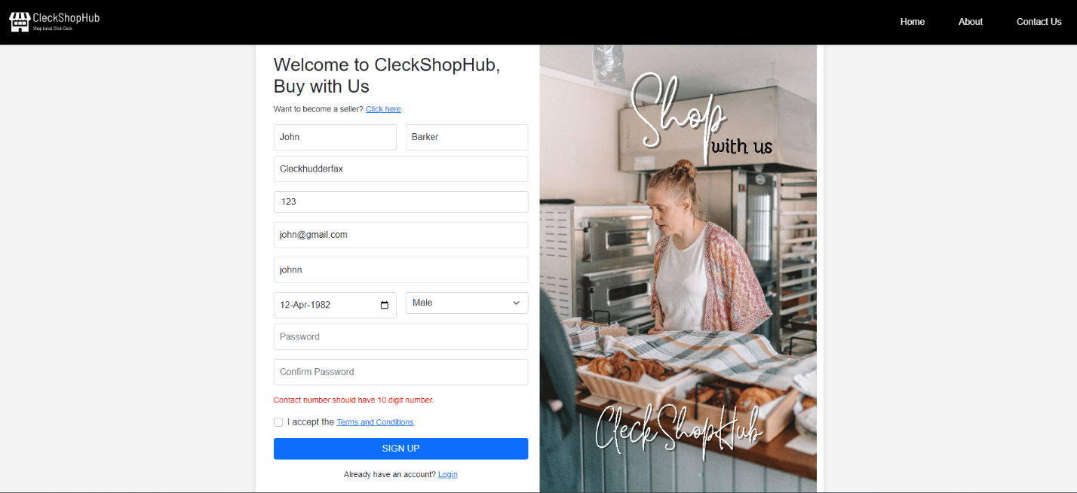

* If you enter a username which is already used by another existing user then a red error message will be displayed informing user that the username already exists

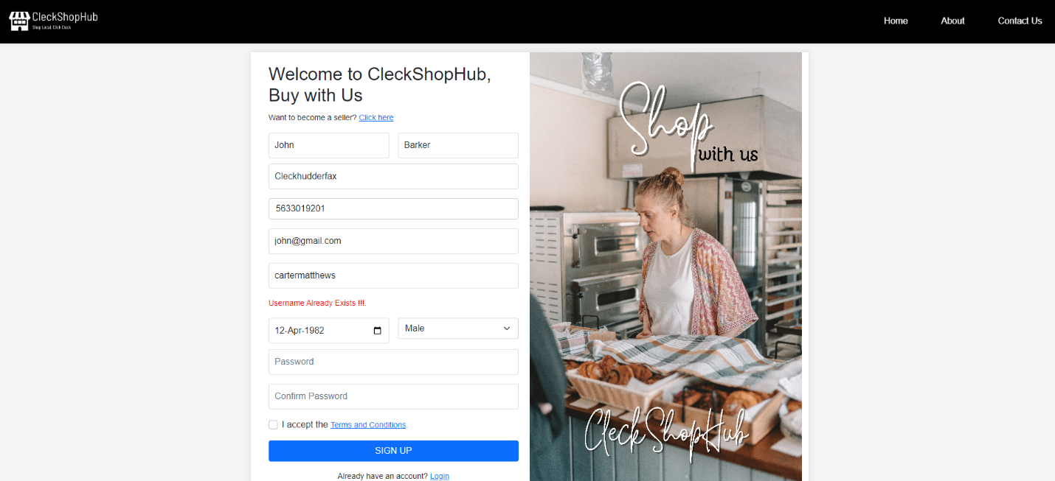

* If the user’s age is less than 12 after entering date of birth then red error message is displayed informing user that he/she is not able to register.
* If the user enters a contact number which is already used by another existing user then the following error is shown



* If the user provides an email address, which is not unique and used by another user then a red error is displayed informing user that the email already exists.

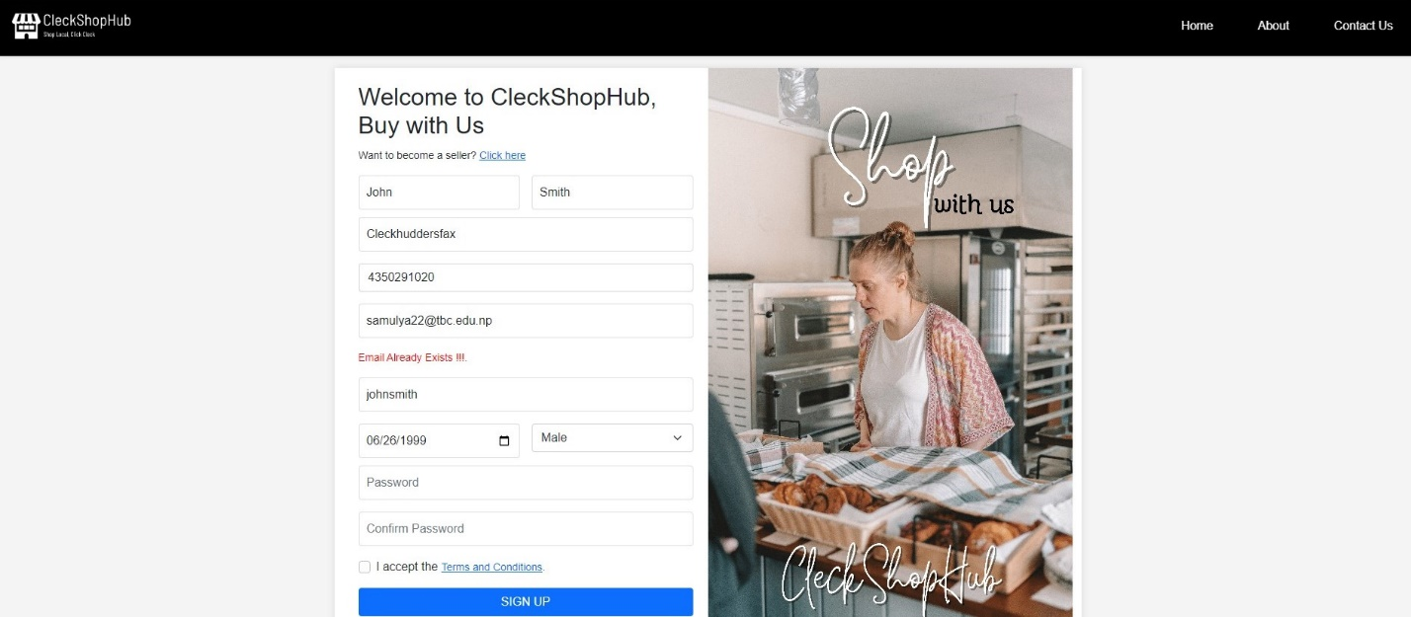

* If the user provides different password in Confirm Password and Password input field then a red error message is displayed informing user that the values doesn’t match

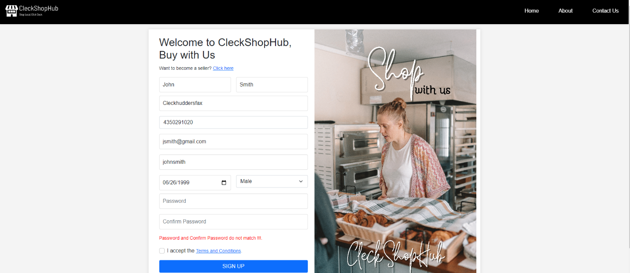

* If the user enters a password that is lesser than 8 or greater than 32 characters then a red error message is displayed asking user to enter a password that is between 8 and 32 characters

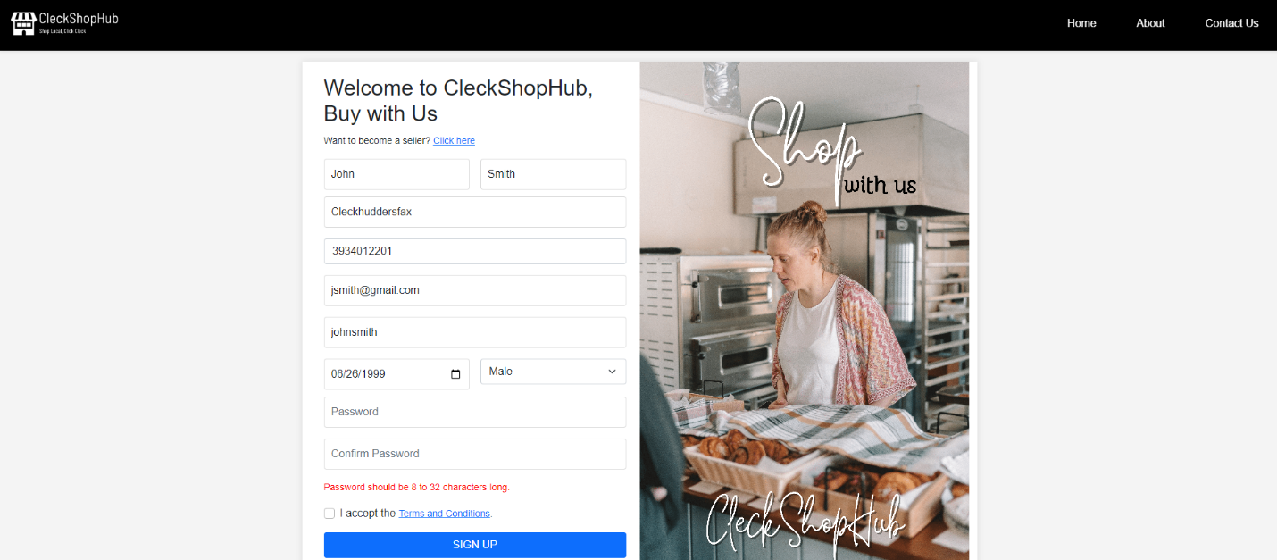

* If the user enters a password that does not contain an uppercase letter, or number or special character then the following error message is shown

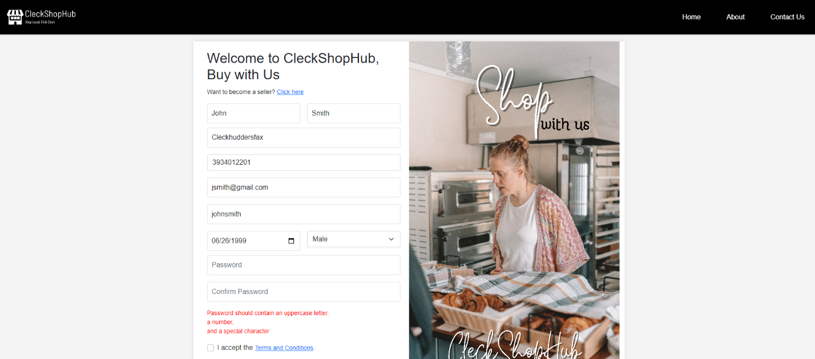

* After registering, the user is prompted to enter the One Time Validation(OTP) code which is sent to their email address

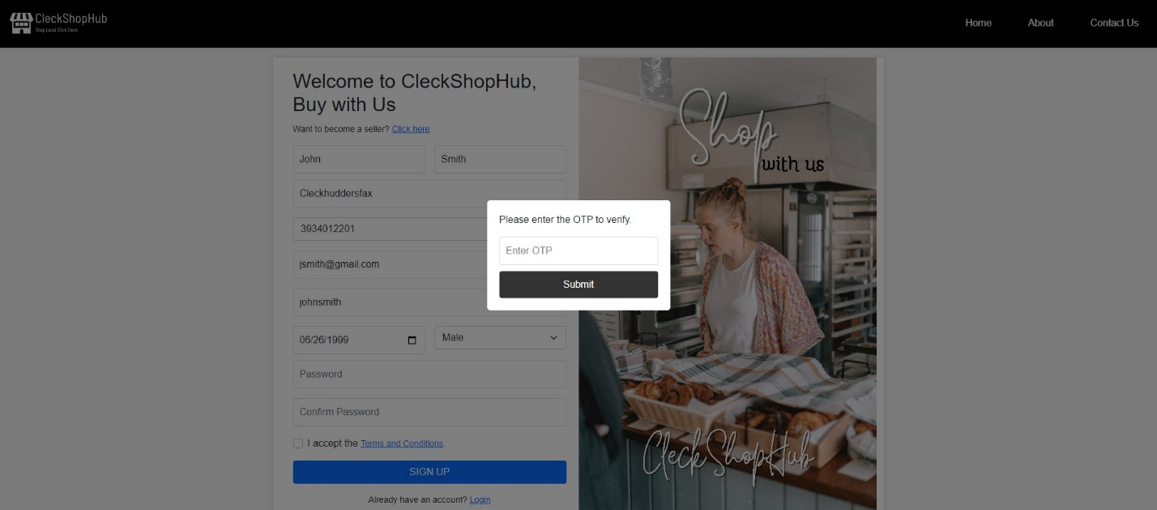

[Login Testing]

* If the user provides empty values in the input fields then the following message will be shown

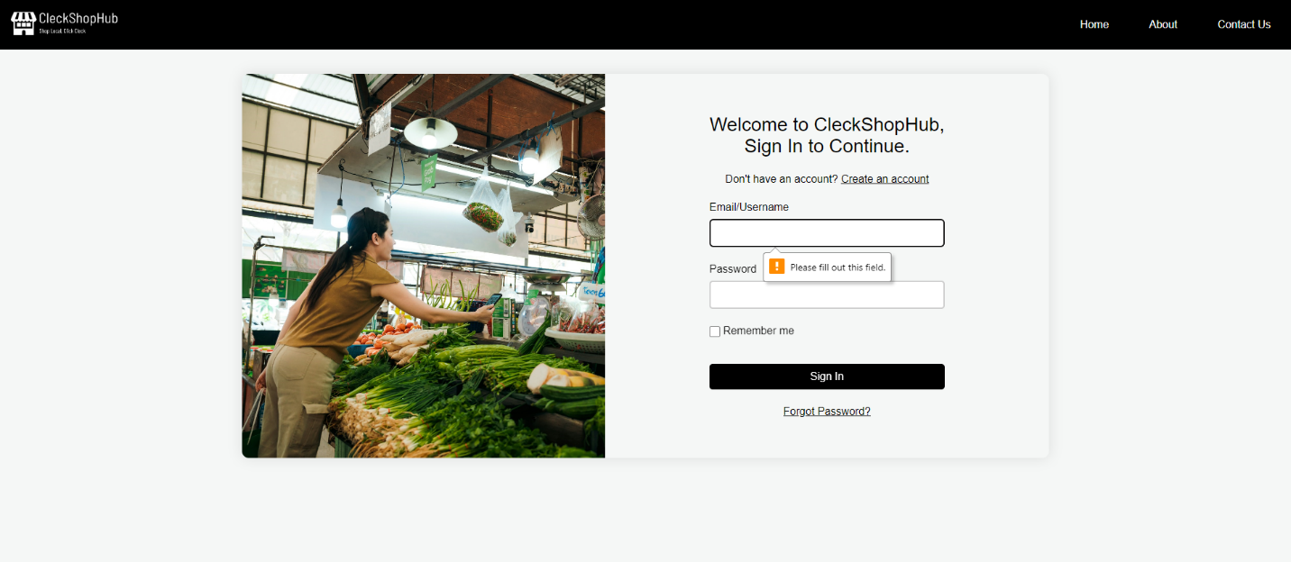

* If the user provides their invalid username or email address then the following error message is

displayed

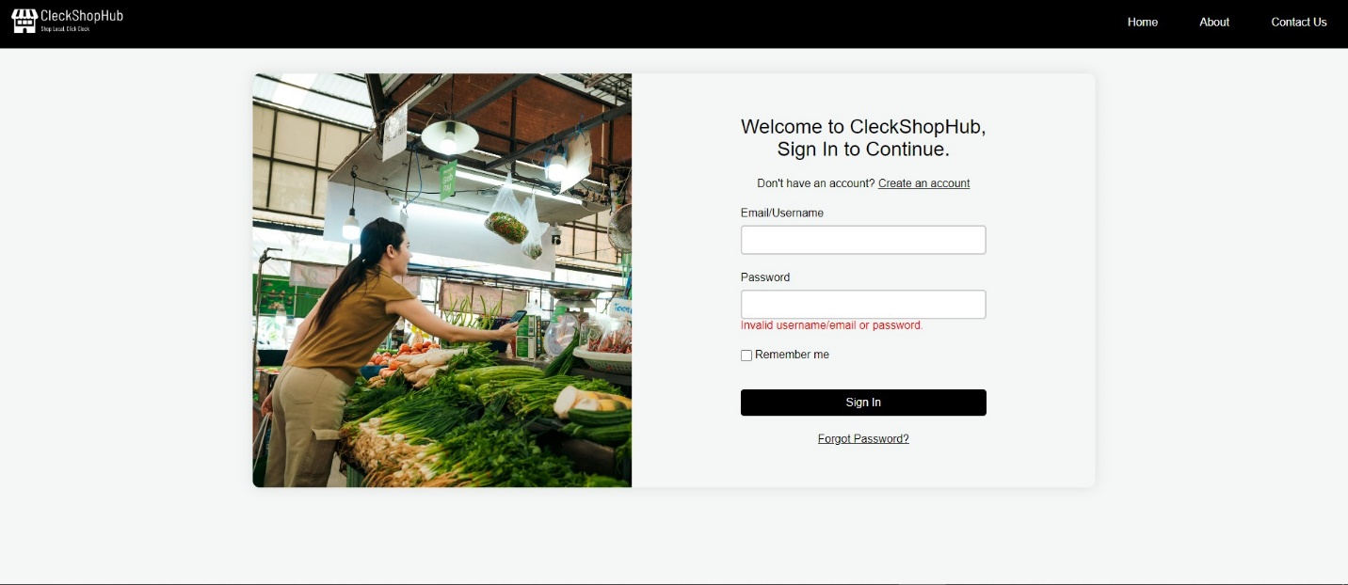

* If the user ticks the Remember Me checkbox, then the user is not required to enter their username or email details again

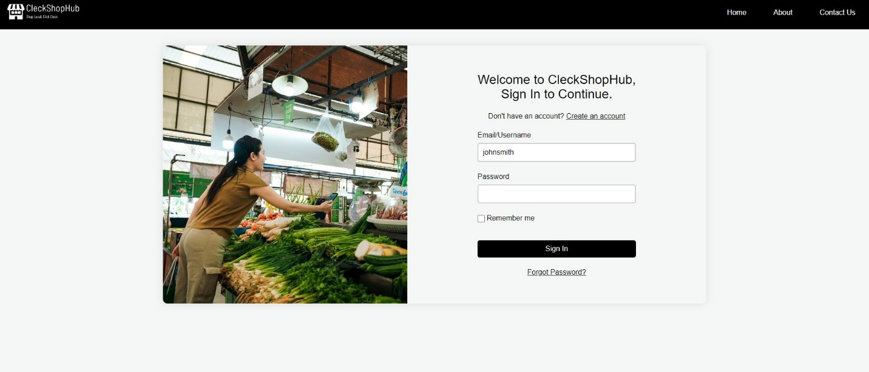

* If the user clicks on forgot password then the user is prompted to provide their email address to receive OTP code for validation and change their password by providing their old password.

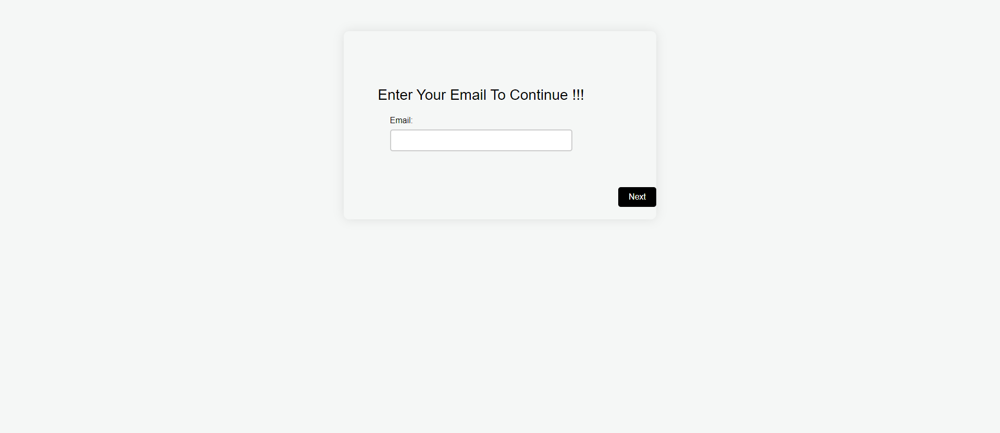

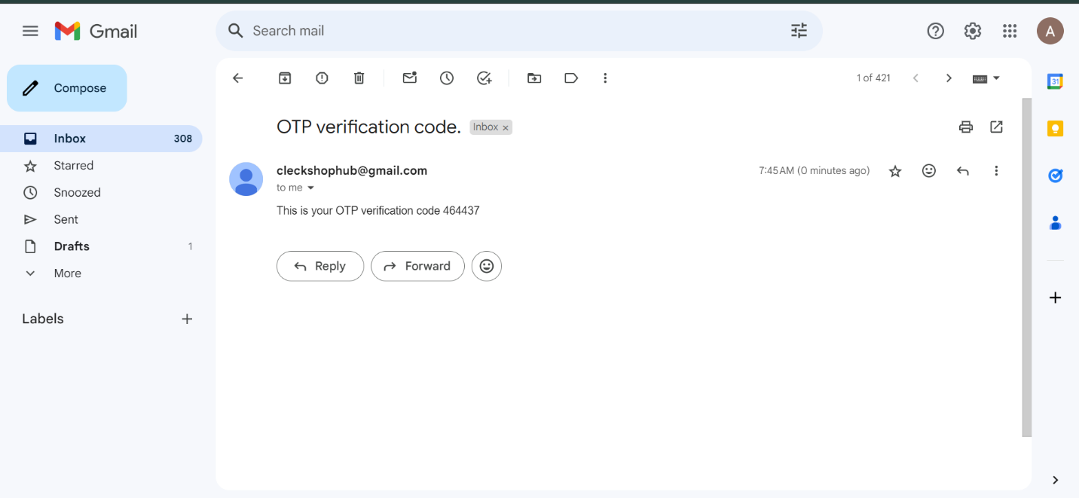

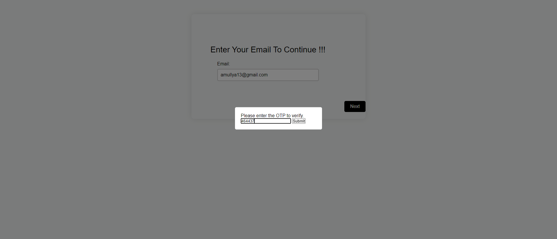

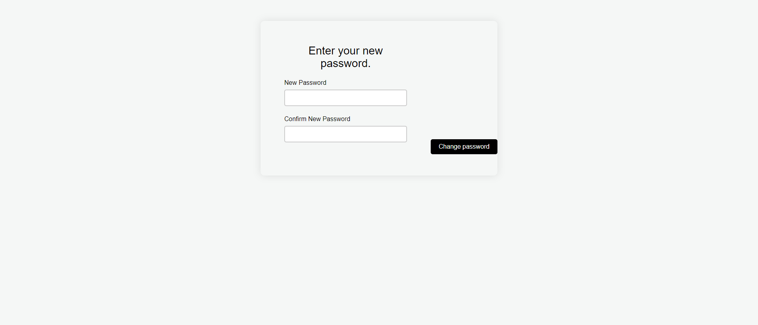

* After user successfully provides their correct username and password then they are directed to homepage.

**[Customer Testing]**

* Customer can view their profile by clicking on the profile icon on top right of the navigation bar

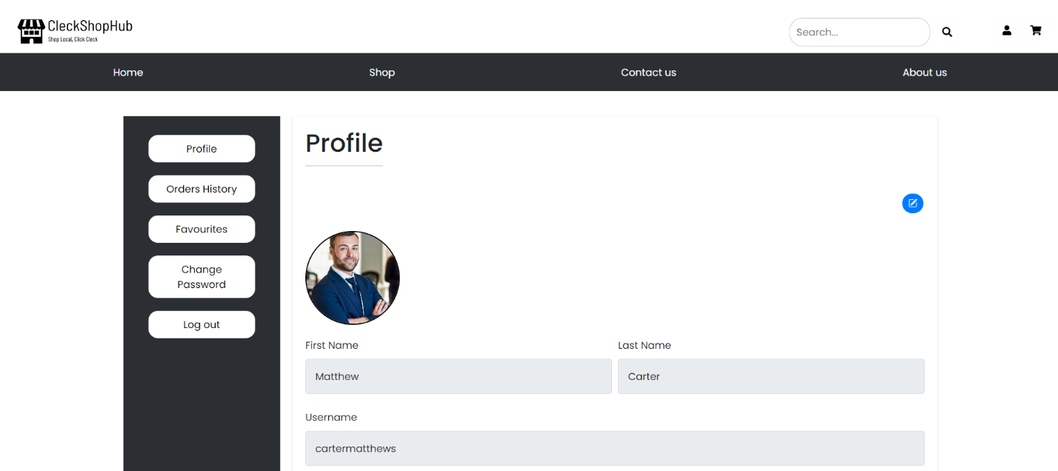

* Customer can update their profile picture by clicking on the blue edit label and upload their images from their system.

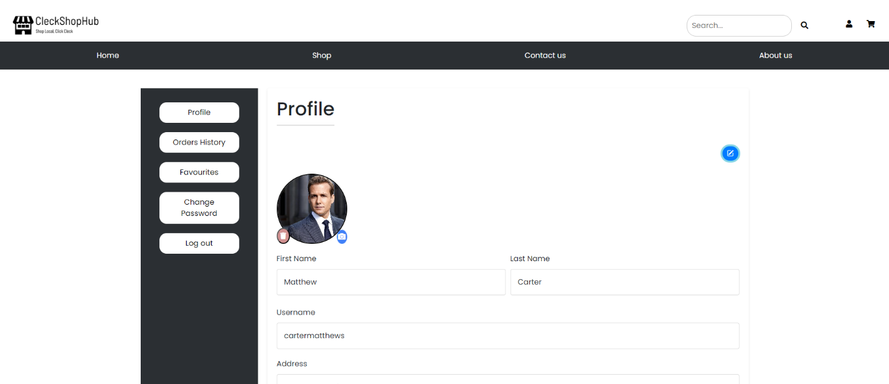

* Customer can check all the items they have favorited after clicking the Favorites tab.

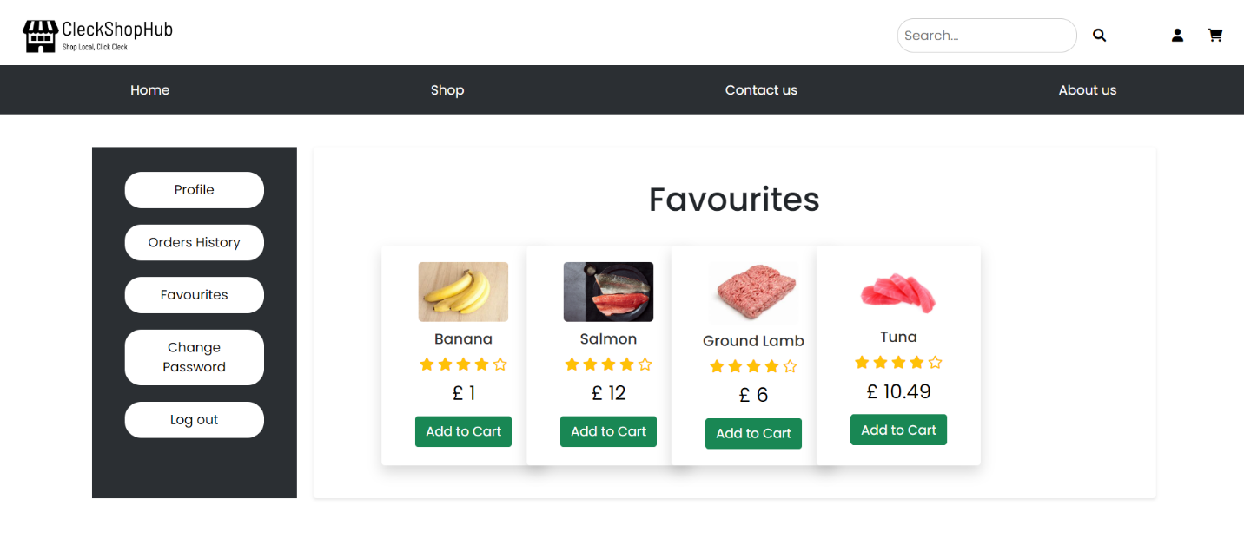

* Customer can check their order history by clicking on the Order History tab from the left side

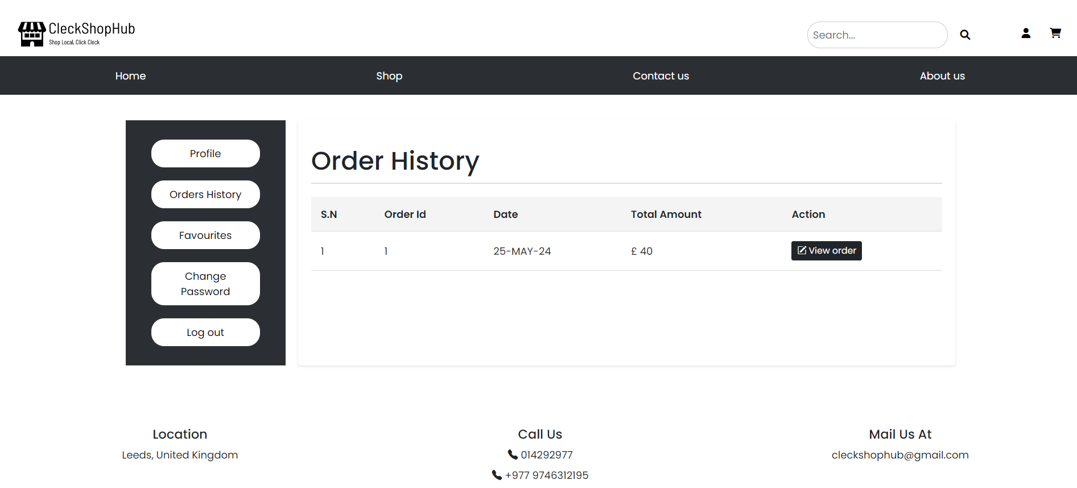

* Customer can change their password after clicking on change password tab

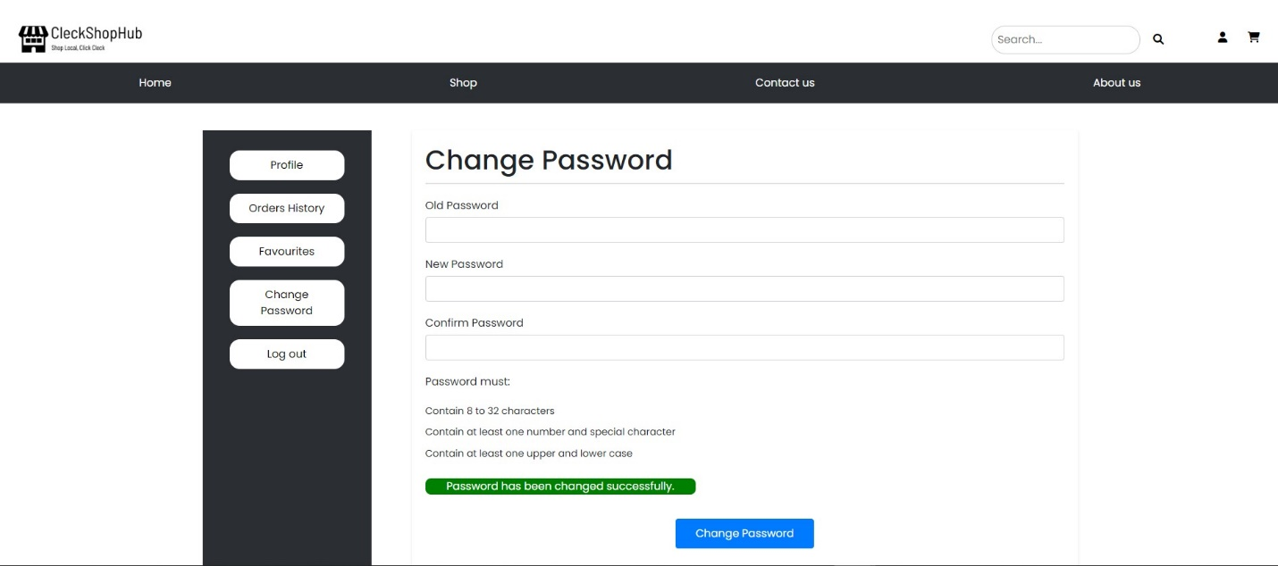

* Customer can log out after clicking on log out button on top right of the navigation bar and they are directed back into the homepage

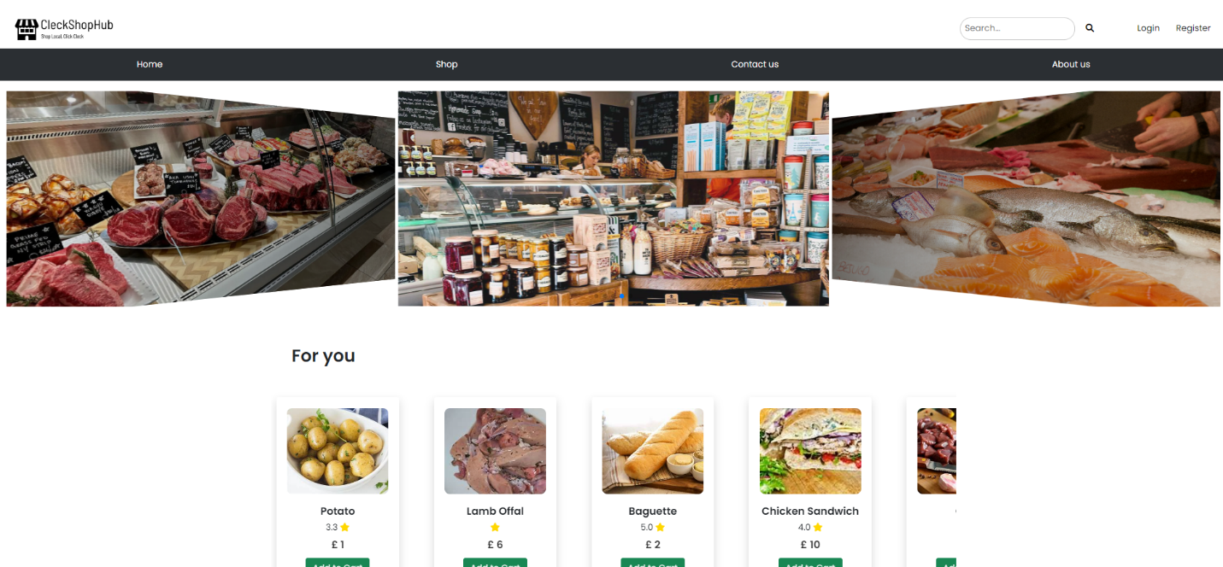

**[Product Testing]**

* Customer can search for a specific product in the search bar in the top of the navigation bar

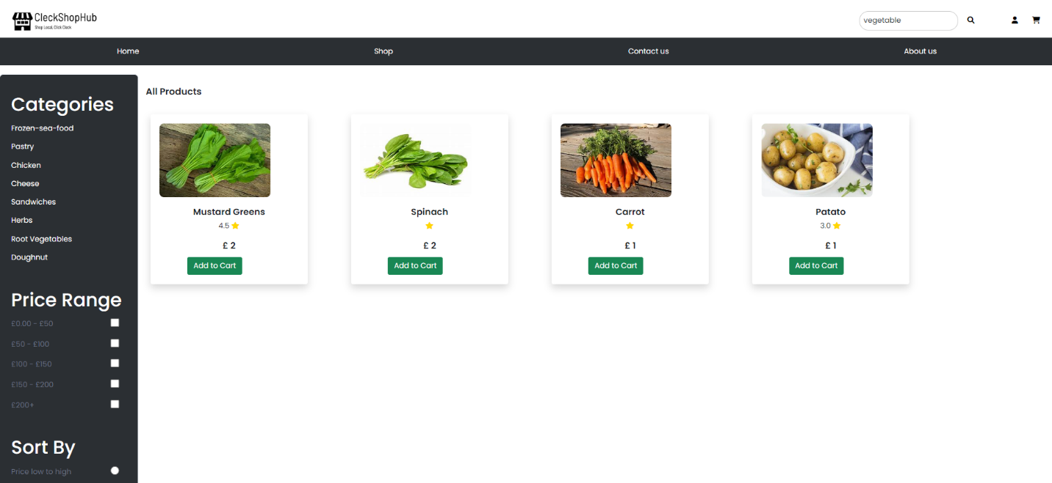

* Customer can add products to their cart after clicking on the add to cart button

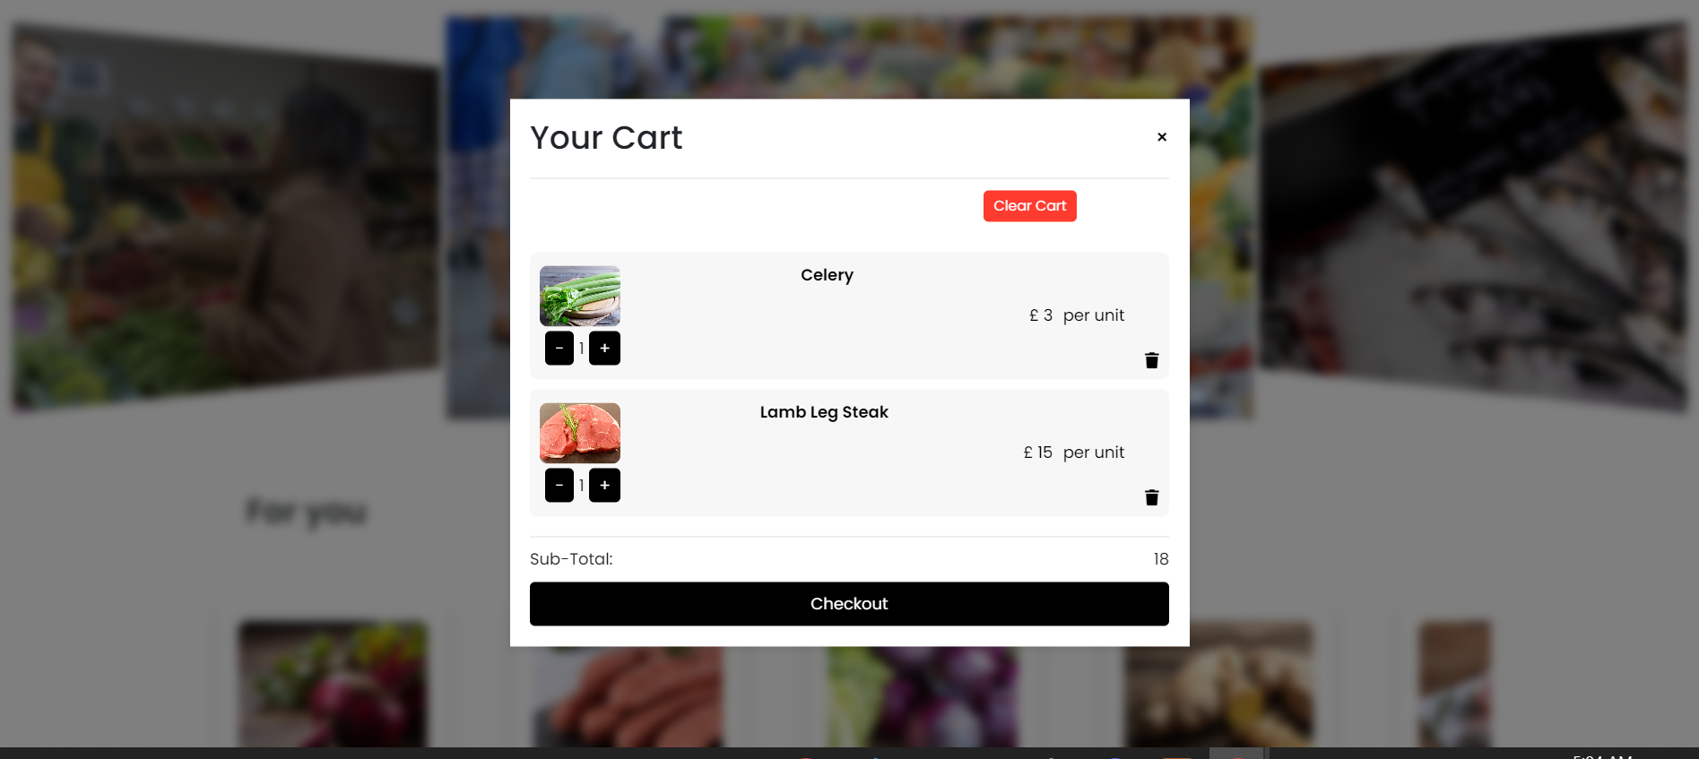

* Customer can add any product in their favorite list after clicking on the red “heart” labelled button

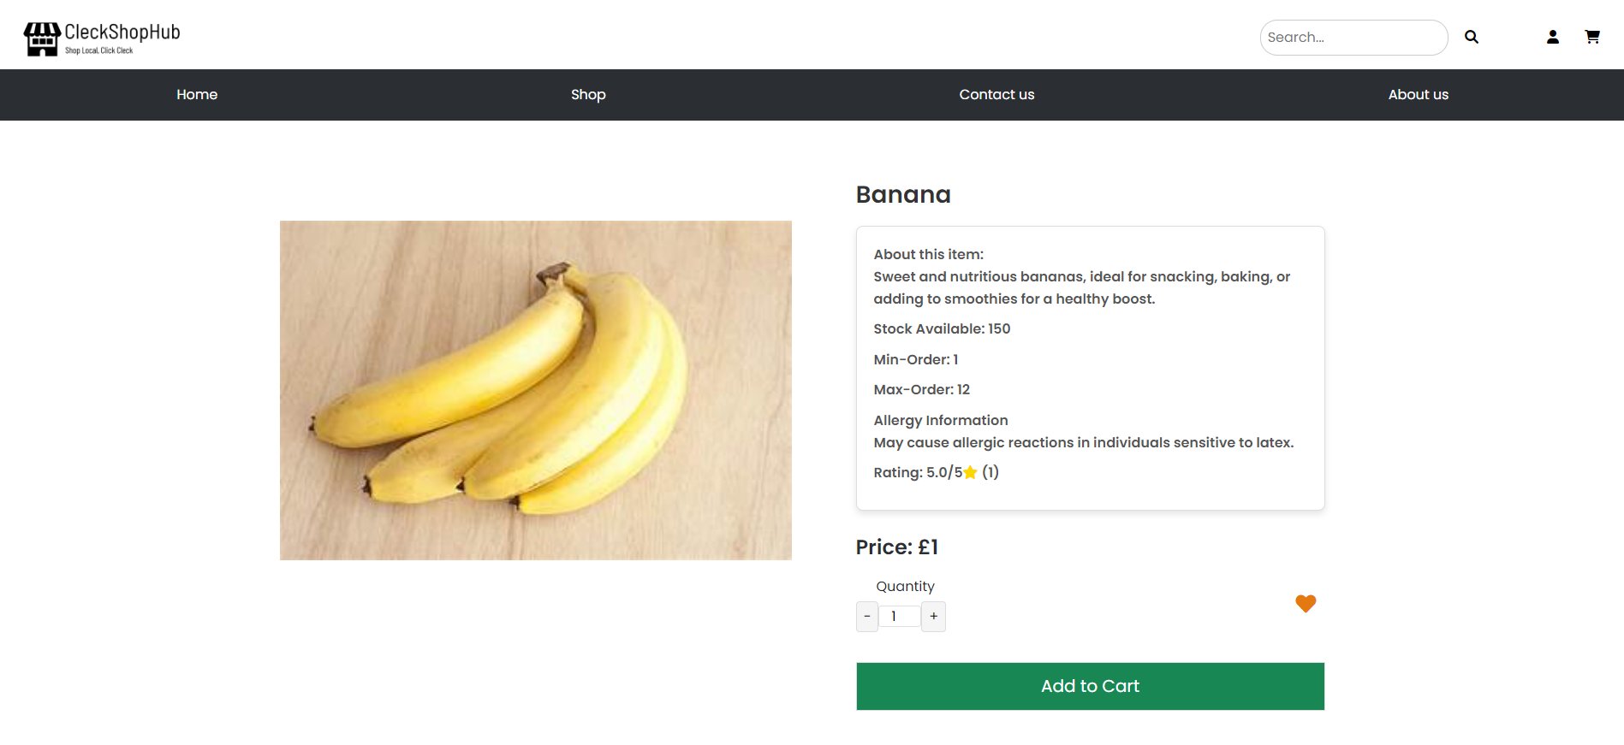

* Customer can check all the review a particular product has after clicking on the product

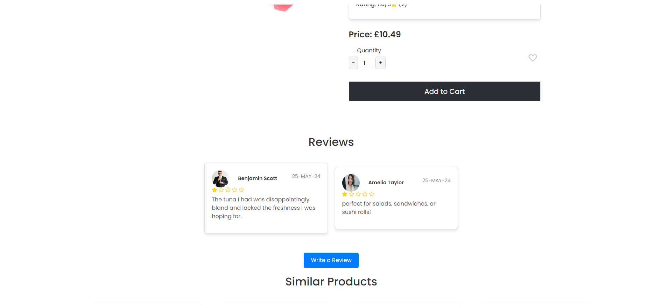

* Customer can check the product details after clicking on a specific product.

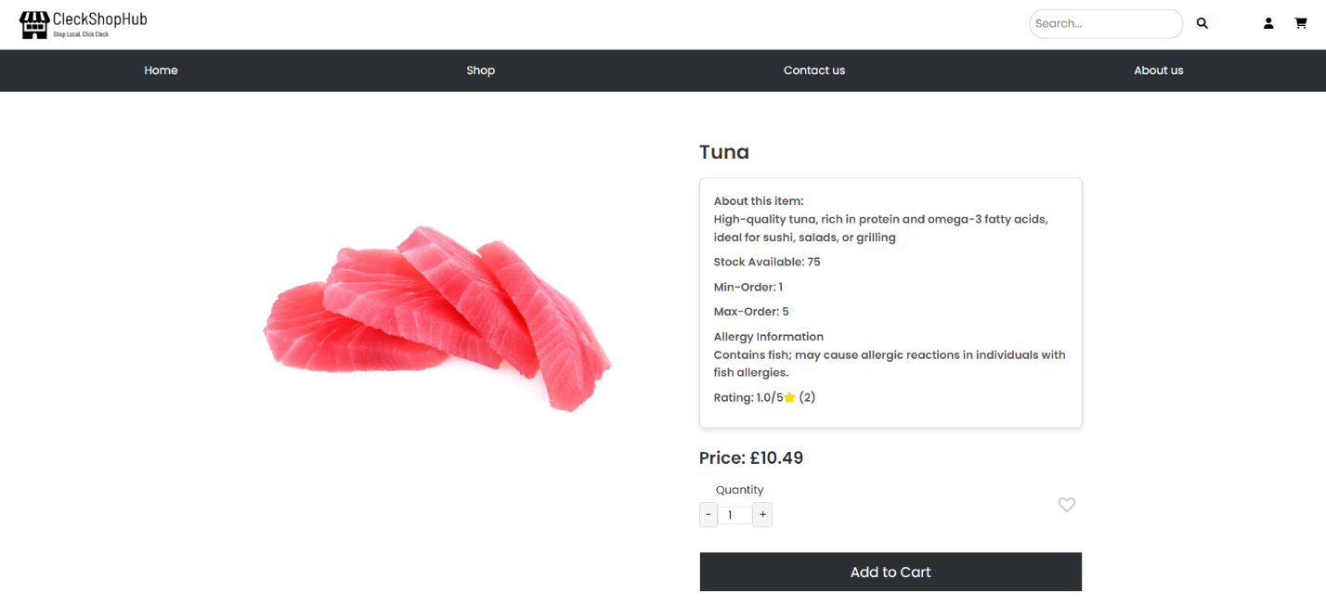

* Customer can write reviews about specific product after clicking on “write a review” labelled button

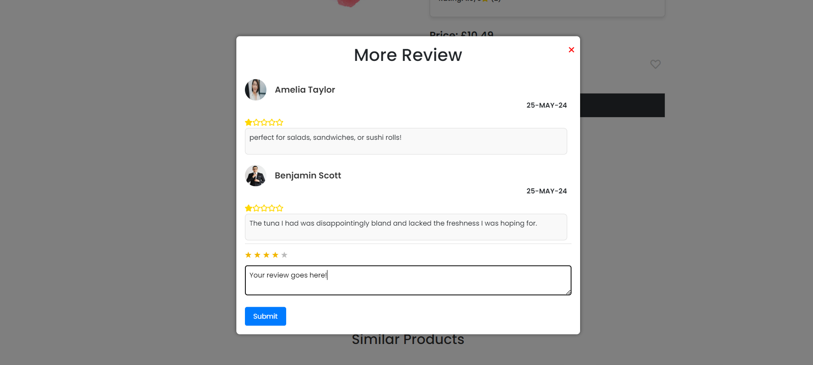

**[Cart Testing]**

* Customer can clear all the items from the cart after clicking on red clear cart labelled button

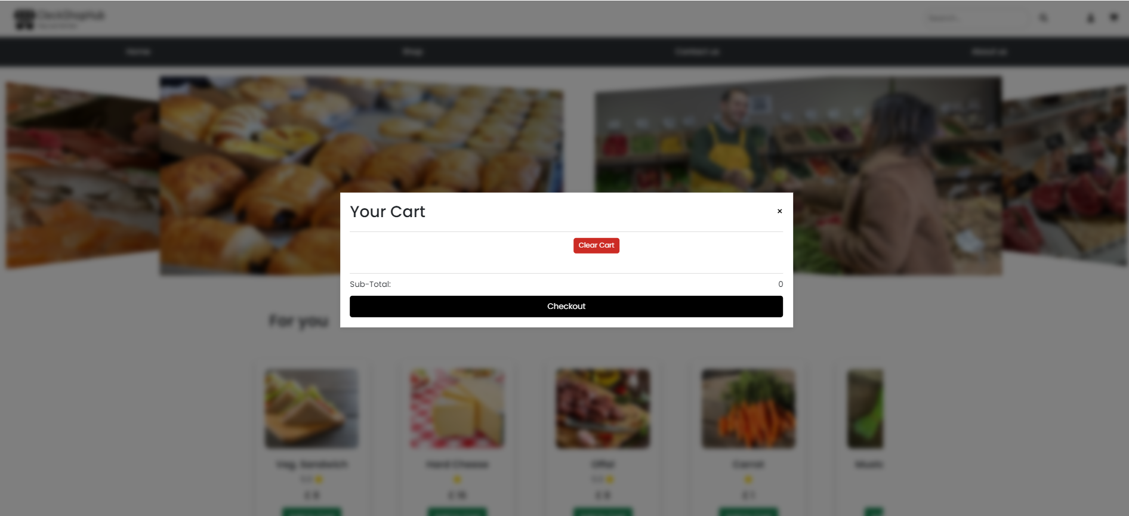

* Customer can increase or decrease the quantity of individual product by clicking on the “+” or “-“ labelled button

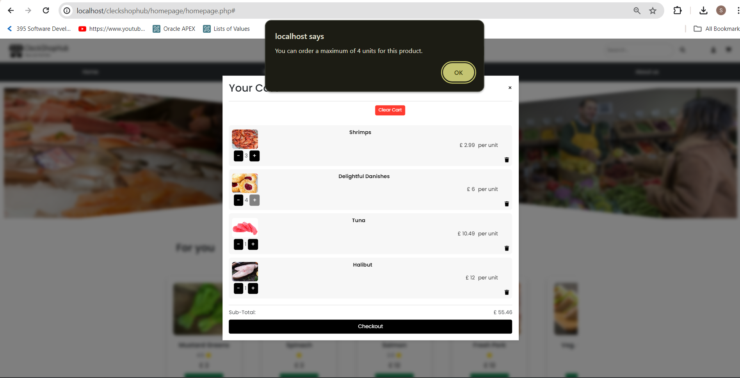

* Customer can know the subtotal of all the product which is displayed in the cart

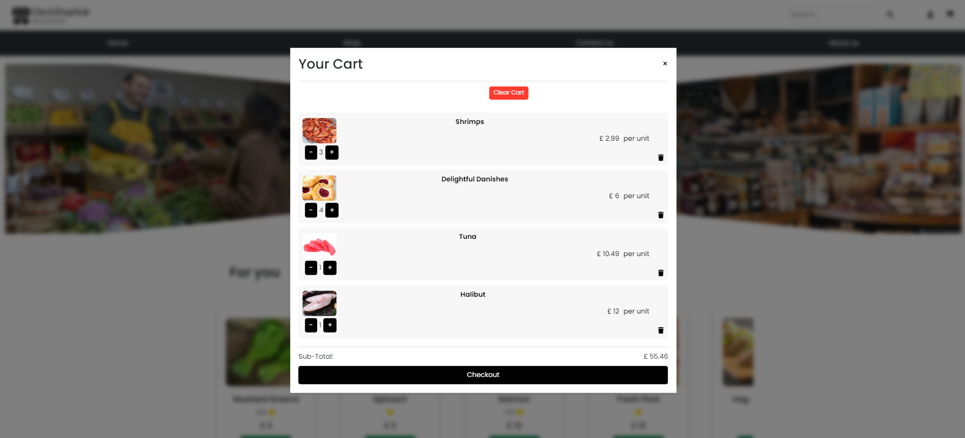

**[Checkout]**

* Customer can proceed to checkout after clicking on the checkout button

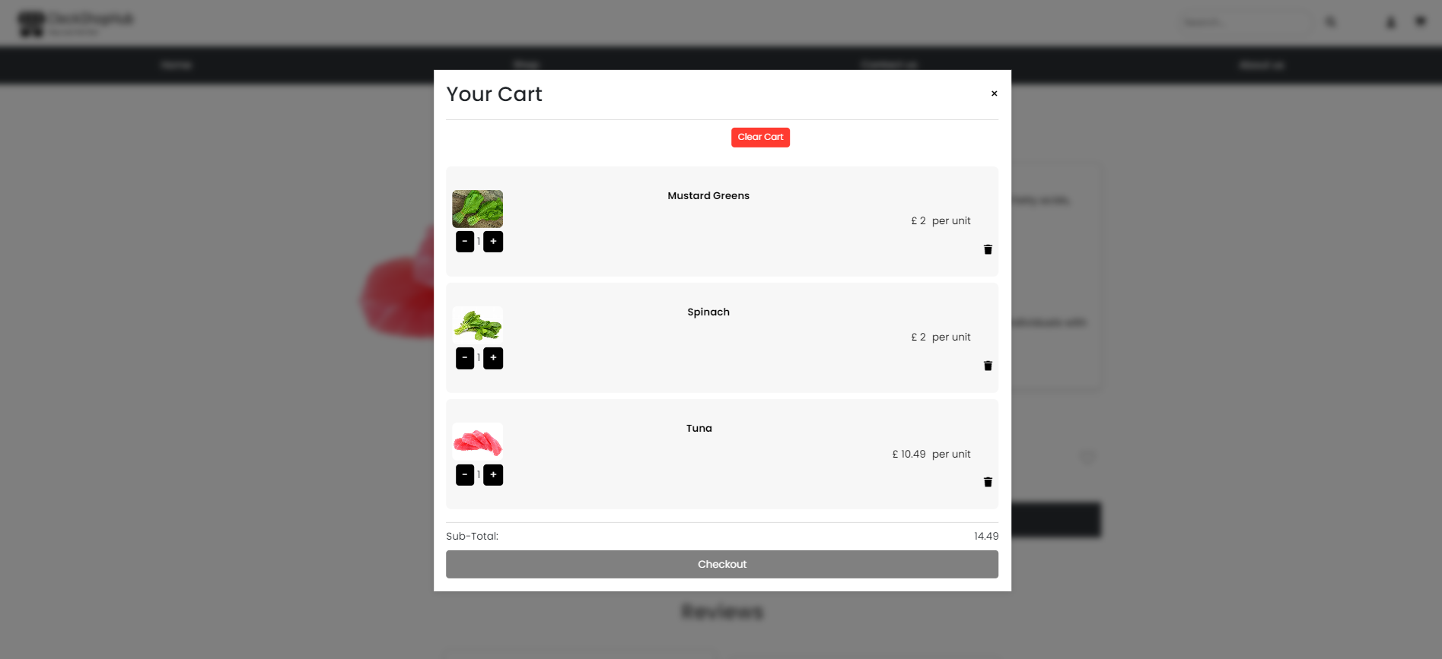

* Customer can select the collection slot during checkout

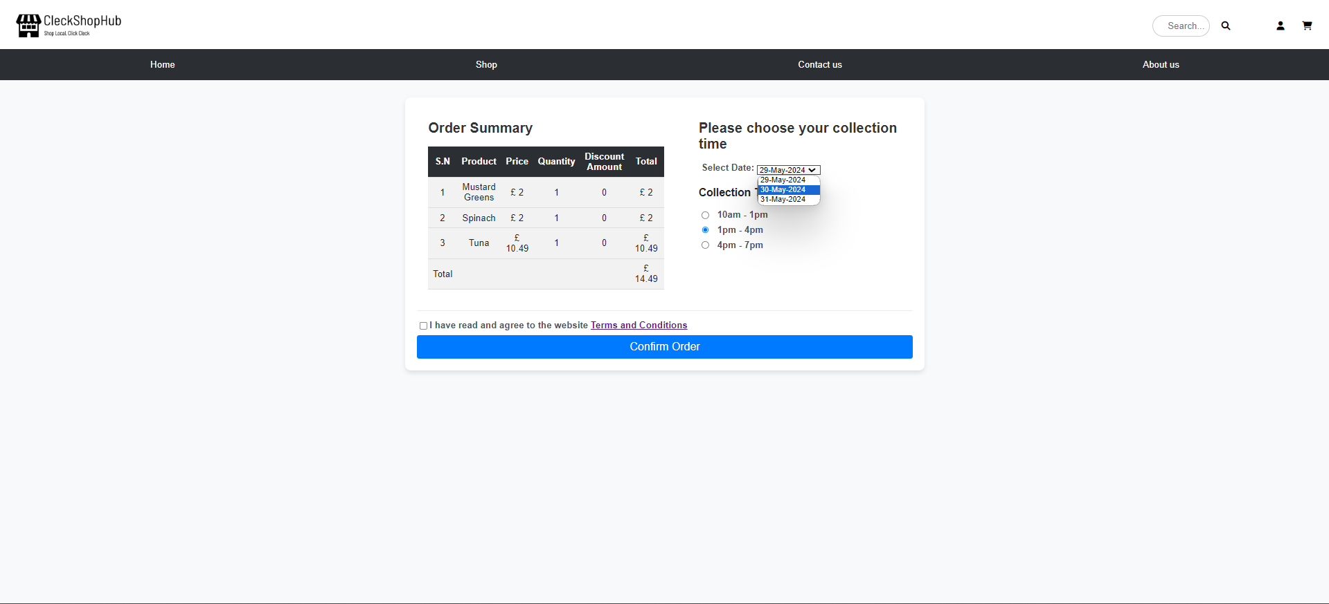

**[Payment]**

* Customer is directed to paypal after checking out

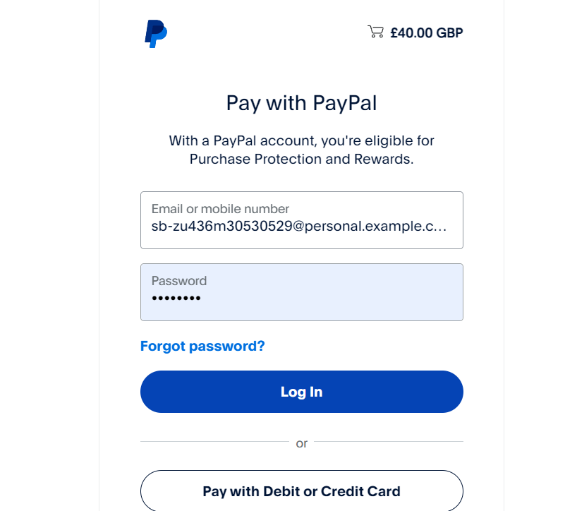

* Customer is prompted complete the payment after entering paypal details to complete the payment

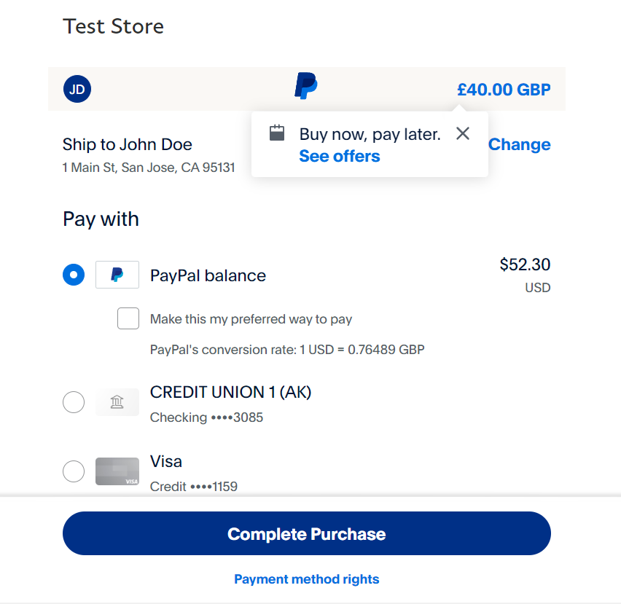

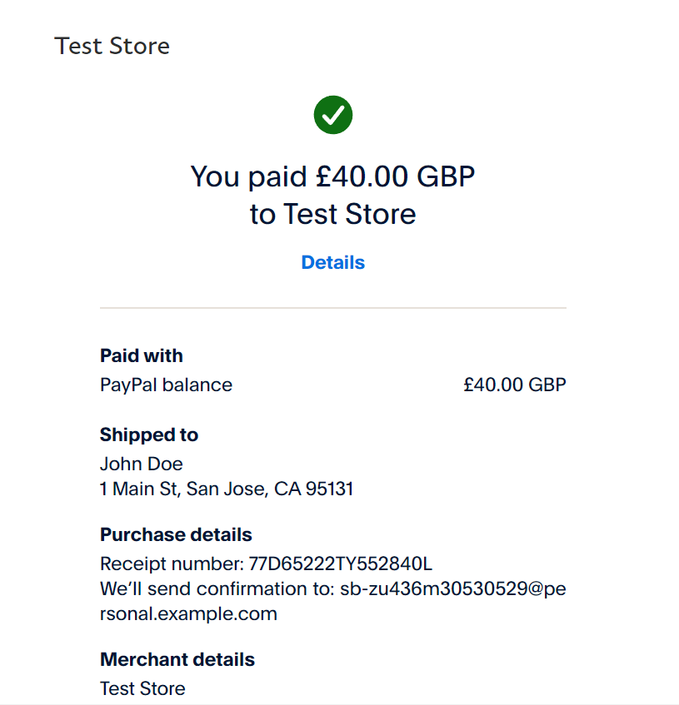

* Customer will receive invoice in their email after completing payment

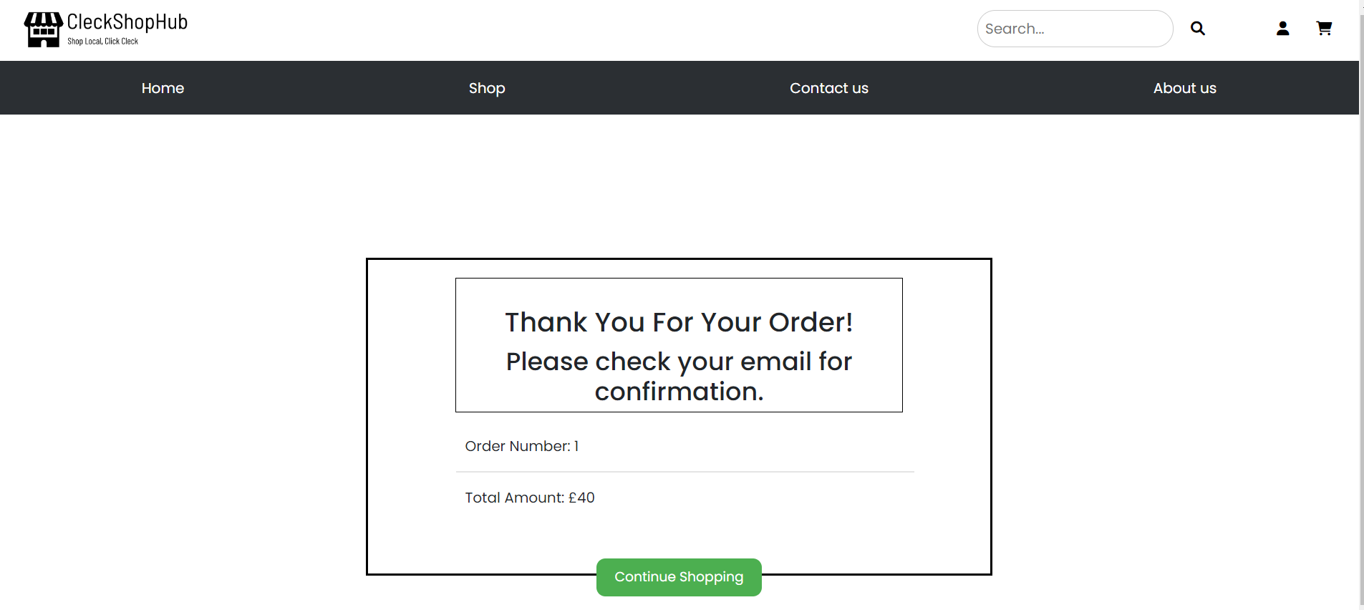

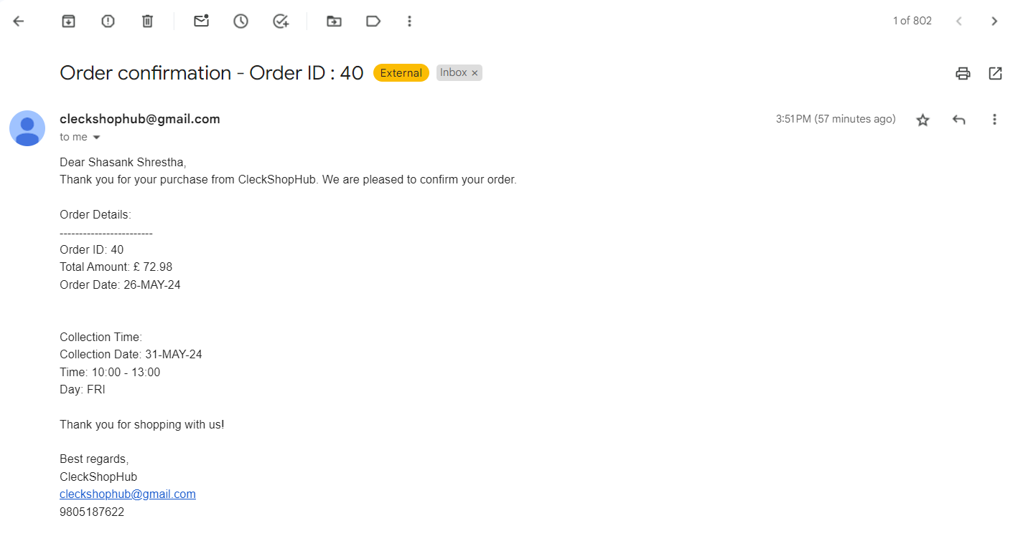

**[About Us]**

* Customer can know more about the website after clicking on the about us tab in the navigation bar

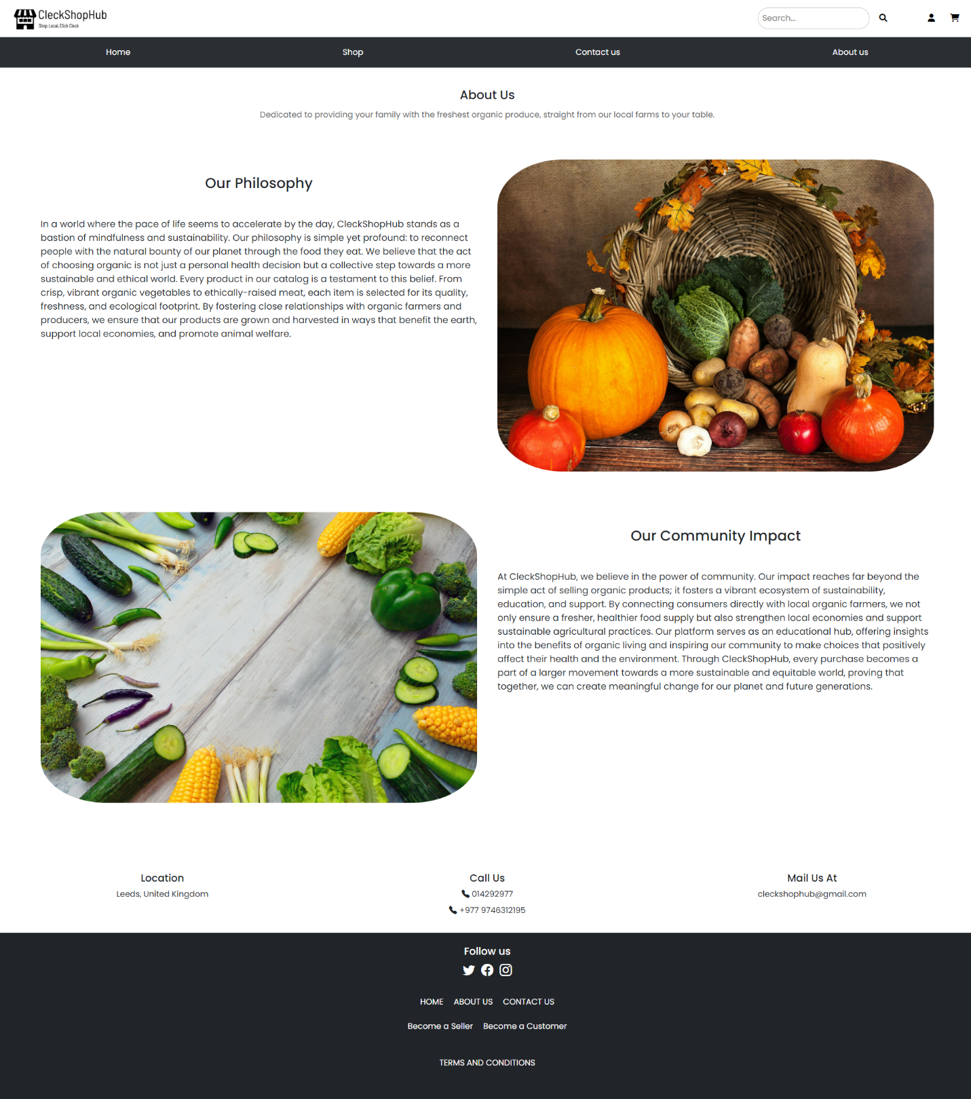

**[Contact Us]**

* Customer can send message or queries to admin, which is fetched to admin panel.

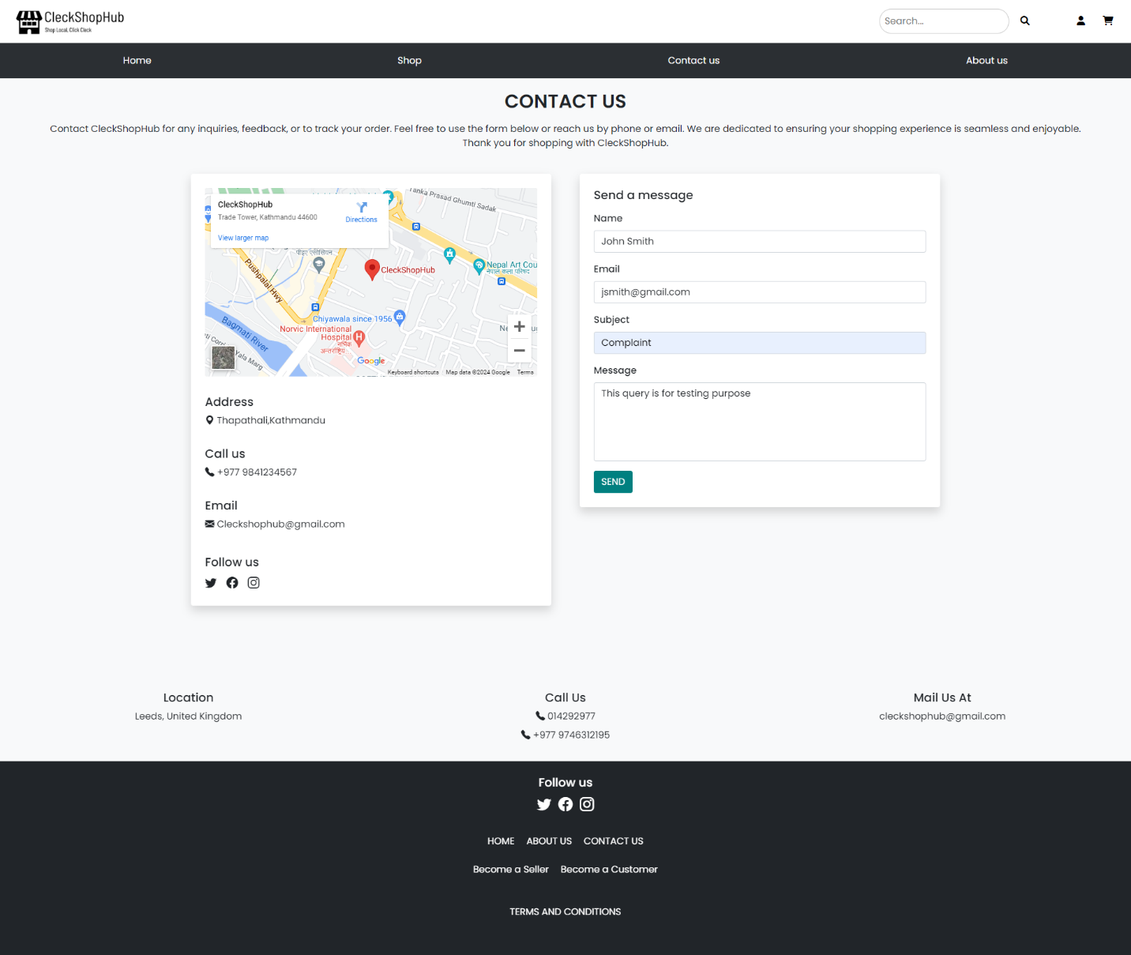

* Customer can check the shop location by interacting with Google Map

